**CG/NHR Health check operation Manual (v 1.2)**

Document Control

|  |  |  |  |  |
| --- | --- | --- | --- | --- |
| **Version**  **Number**  n.n | **Issued**  **On Date**  YYYY/MM/DD | **Author(s)**  First name & Surname  & Title | **Reviewer(s)**  First name & Surname  & Title | **Change Description** |
| 1.0 | 2016/12/05 | Wang Shichao |  | Document creation |
| 1.1 | 2016/12/17 | Edward Leung |  | Add back Operation Information |
| 1.2 | 2017/01/11 | Edward Leung |  | Email address revision |
|  |  |  |  |  |
|  |  |  |  |  |
|  |  |  |  |  |
|  |  |  |  |  |

**TABLE OF CONTENTS**

1. objective 4

2. architecture overview 5

2.1 Architecture Diagram (Notification Triggered by Core System Generated Notification Files) 5

2.2 Architecture Diagram (Notification Triggered by Web Service Call from iPro/SCRUM) 6

2.3 Server Table 7

3. Health check summary 8

4. Health Check schedule 9

5. Health check Task Details 10

5.1 Task T1 – Check CG Web 10

5.1.1 Health check steps 10

5.1.2 Recovery Steps 11

5.2 Task T2 – Check Core System sent files to CG 12

5.2.1 Health check steps 12

5.2.2 Recovery Steps 14

5.3 Task T3 – Check any error file for daily download 15

5.3.1 Health check steps 15

5.3.2 Recovery Steps 17

5.4 Task T4 – Check RCMS sent files to CG 18

5.4.1 Health check steps 18

5.4.2 Recovery Steps 20

5.5 Task T5 – Check any error in RCMS files 21

5.5.1 Health check steps 21

5.5.2 Recovery Steps 23

5.6 Task T6 – Check Number of Notifications Send Out 24

5.6.1 Health check steps 24

5.6.2 Recovery Steps 26

6. Appendix 27

6.1 Communications 27

# objective

This documents is written for S&M members to carry out detailed health check procedures for NHR system. In order to ensure NHR system is functioning properly, periodic health check is required to carry out by S&M members. For any un-expected behaviours observed by S&M members, they can carry out remedial steps or contact support parties for incident investigation.

This document is for AXA internal use only.

# architecture overview

## Architecture Diagram (Notification Triggered by Core System Generated Notification Files)

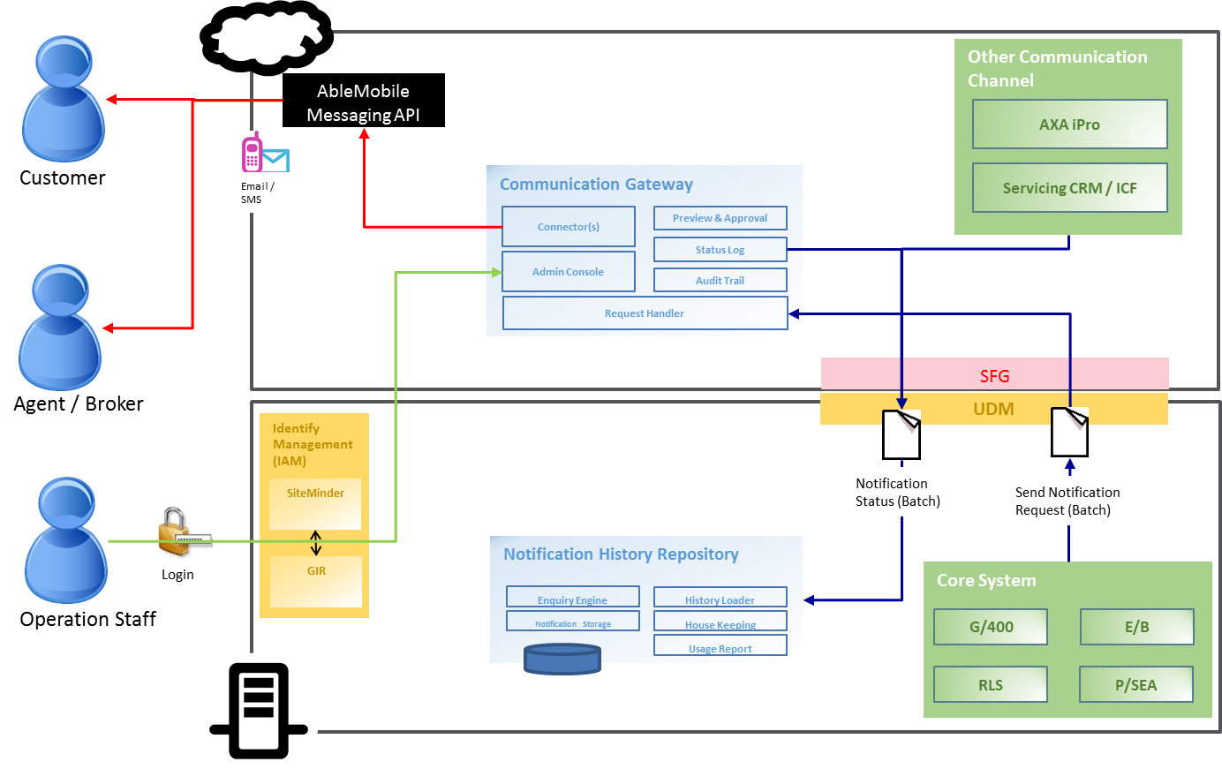

CG

NRH

## Architecture Diagram (Notification Triggered by Web Service Call from iPro/SCRUM)

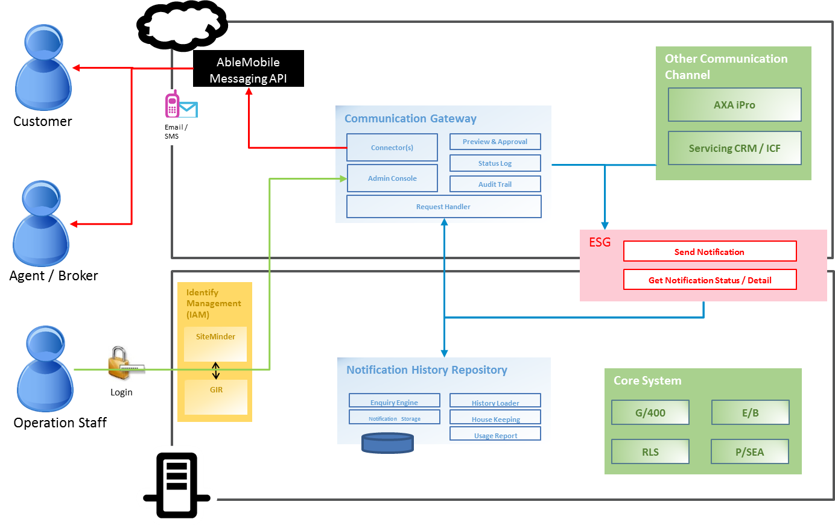

CG

NRH

## Server Table

CG Server Table

|  |  |  |
| --- | --- | --- |
| **Application Components** | **Host Name** | **IP Address** |
| Active Directory Domain server / SQL Witness Server | HKWVAPAXA01 | 172.29.50.21 |
| Active Directory Domain server / SQL Witness Server (DR) | HKWVASAXA01 | 172.29.52.25 |
| Application Proxy server | HKWVAPAXA02 | 172.29.42.22 |
| Application Proxy server (DR) | HKWVASAXA02 | 172.29.42.26 |
| Application server | HKWVAPAXA04 | 172.29.52.24 |
| Application server/Communication Gateway (HA) (DR) | HKWVASAXA04 | 172.29.52.28 |
| Database server / Communication Gateway | HKWVAPAXA03 | 172.29.52.23 |
| Database server/Communication Gateway(DR) | HKWVASAXA03 | 172.29.52.27 |

NHR Server Table

|  |  |  |
| --- | --- | --- |
| **Application Components** | **Host Name** | **IP Address** |
| Active Directory Domain server / SQL Witness Server | HKLVAUAXA01A | 172.29.52.29 |
| Active Directory Domain server / SQL Witness Server (DR) | HKLVAUAXA01B | 172.29.52.32 |
| Application Proxy server | HKLVAUAXA02A | 172.29.42.27 |
| Application Proxy server (DR) | HKLVAUAXA02B | 172.29.42.28 |
| Application server Communication Gateway (HA) | HKLVAUAXA04A | 172.29.52.31 |
| Application server/Communication Gateway (HA) (DR) | HKLVAUAXA04B | 172.29.52.34 |
| Database server Communication Gateway | HKLVAUAXA03A | 172.29.52.30 |
| Database server/Communication Gateway(DR) | HKLVAUAXA03B | 172.29.52.33 |

# Health check summary

|  |  |  |
| --- | --- | --- |
| **Task ID** | **Task Description** | **Section** |
| T1 | Check CG Web | 5.1 |
| T2 | Check Core System sent files to CG | 5.2 |
| T3 | Check any error file for daily download | 5.3 |
| T4 | Check RCMS sent files to CG | 5.4 |
| T5 | Check any error in RCMS files | 5.5 |
| T6 | Check Number of Notifications Send Out | 5.6 |

# Health Check schedule

|  |  |  |  |  |  |  |  |
| --- | --- | --- | --- | --- | --- | --- | --- |
| **#** | **Type of Health Check** | **Schedule time** | | **Estimated Duration** | **Health Check Steps** | | **Section** |
| **From** | **To** |  |
| 1 | Check CG Web | 8:25 HKT | 8:30 HKT | 5mins | 1 | T1 | 5.1 |
| 2 | Check Core System sent files to CG | 8:30 HKT | 8:35 HKT | 5mins | 1 | T2 | 5.2 |
| 3 | Check any error file for daily download | 8:35 HKT | 8:40 HKT | 5mins | 1 | T3 | 5.3 |
| 4 | Check RCMS sent files to CG | 8:40 HKT | 8:45 HKT | 5mins | 1 | T4 | 5.4 |
| 5 | Check any error in RCMS files | 8:45 HKT | 8:50 HKT | 5mins | 1 | T5 | 5.5 |
| 6 | Check Number of Notifications Send Out | 13:00 HKT | 13:15 HKT | 15mins | 1 | T6 | 5.6 |

# Health check Task Details

## Task T1 – Check CG Web

This check helps to ensure the running of CG web application server. The successful display of application screen showing that the CG system which is hosted in cloud system is running.

### Health check steps

|  |  |  |  |  |  |
| --- | --- | --- | --- | --- | --- |
| **Task ID** | **Team** | **Env/Server** | **Steps** | **Expect Results** | **Actions** |
| T1.1 | NHR support  team | NHR production system | 1. Go to login page.  https://www.e-serivce-axa.com.hk/axa-notification-web | Login screen appears. | 1. Check SiteMinder 2. Report incident to Atos |

Figure 5.1.1

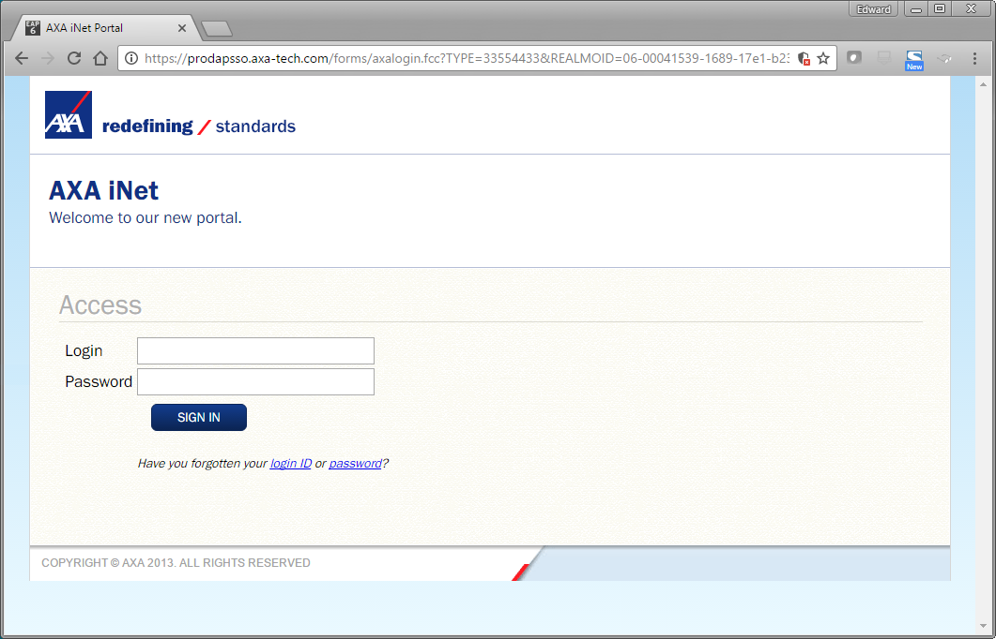

### Recovery Steps

|  |  |  |  |
| --- | --- | --- | --- |
| **Recovery ID** | **Team** | **Env/Server** | **Steps** |
| R1.1 | NHR support team | NHR production system | 1. Check whether other AXA internals application working or not. If they cannot work, it means that SiteMinder failed 2. Contact SiteMinder team for follow up. 3. If support team member can access to other system, there is problem in CG server. Contact ATOS and report incident to ATOS |

## Task T2 – Check Core System sent files to CG

This check helps to ensure the core systems have daily notification files downloaded to the sftp server of CG.

### Health check steps

|  |  |  |  |  |  |
| --- | --- | --- | --- | --- | --- |
| **Task ID** | **Team** | **Env/Server** | **Steps** | **Expect Results** | **Actions** |
| T2.1 | NHR support  team | NHR production system | 1. Login to CG Web Page <https://www.e-service-axa.com.hk/axa-notification-web>  2. Go to Notification Source Upload Page  3. Input T-1 business date and search  4. Check all files can be received | Expected number of files received | 1. Check sftp connectivity 2. Report incident to Atos if sftp down 3. Check G400 / EB / PSEA / RLS if sftp connectivity is OK |

Figure 5.2.1

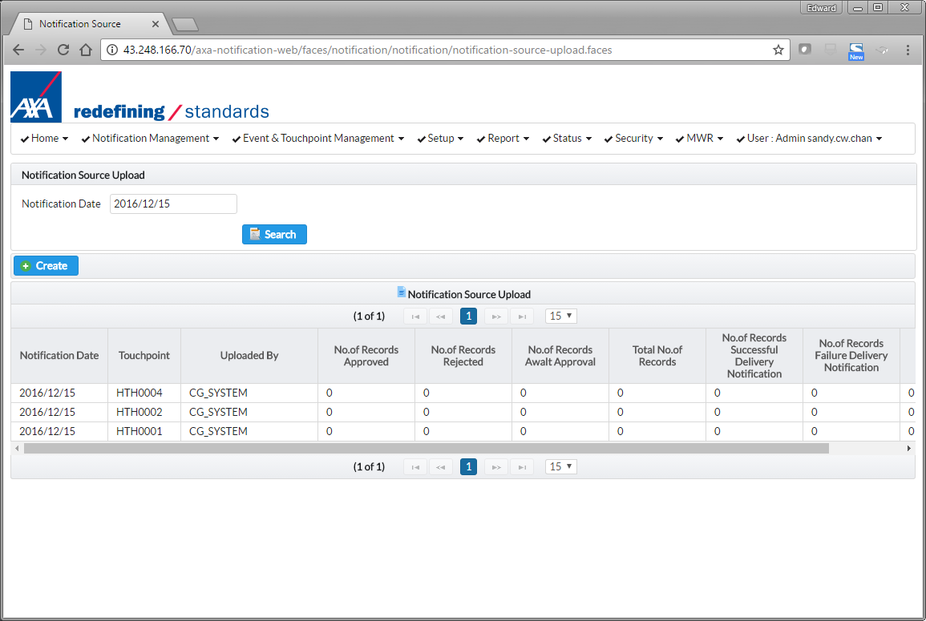

Input T-1 date and click Search

### Recovery Steps

|  |  |  |  |
| --- | --- | --- | --- |
| **Recovery ID** | **Team** | **Env/Server** | **Steps** |
| R2.1 | NHR support team | NHR production system | 1. Login in to sftp.e-service-axa.com.hk  2. If sftp server didn’t work, report incident to ATOS system support team  3. Go to /cygdrive/d/repos/cg/input/NotificationSource/core/backup  4. If there are files of the T-1 date found in the folder for the T-1 date, report the incident to ATOS  For example, a certain touch point, there is not record found in CG Web but the related file can be found in the sftp server. It means:  For LIFE business line, file prefix is: RSNB, RSPP, RSPC For Group Health business line, file prefix is: GPPNDCLM For Individual Health business line, file prefix is: ZE For P&C business line, file prefix is: CLAP, CLSB, ENIS, ENSB, NBIS, RNWI, RTNM |

## Task T3 – Check any error file for daily download

This check helps to ensure there is no error encountered during the processing of core system notification files.

### Health check steps

|  |  |  |  |  |  |
| --- | --- | --- | --- | --- | --- |
| **Task ID** | **Team** | **Env/Server** | **Steps** | **Expect Results** | **Actions** |
| T3.1 | NHR support  team | NHR production system | 1. Login to sftp server.  2. Go to /cygdrive/d/repos/cg/input/NotificationSource/core/error.  3. Check whether there are error files. | There should be **NO** error file found in the folder. | Report incident to business users if there is error file found. |

Figure 5.3.1

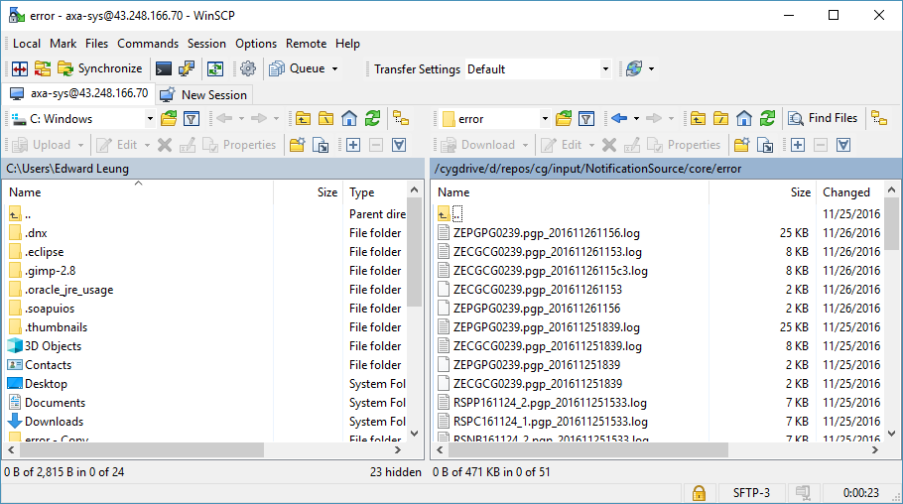

Check any error file in the folder

### Recovery Steps

|  |  |  |  |
| --- | --- | --- | --- |
| **Recovery ID** | **Team** | **Env/Server** | **Steps** |
| R3.1 | NHR support team | NHR production system | 1. Login in to sftp.e-service-axa.com.hk.  2. If sftp server didn’t work, report incident to ATOS system support team.  3. Go to /cygdrive/d/repos/cg/input/NotificationSource/core/error.  4. If there are files of the T-1 date found in the error folder for the T-1 date, send the files to related business team users.  For LIFE business line, file prefix is: RSNB, RSPP, RSPC For Group Health business line, file prefix is: GPPNDCLM For Individual Health business line, file prefix is: ZE For P&C business line, file prefix is: CLAP, CLSB, ENIS, ENSB, NBIS, RNWI, RTNM |

## Task T4 – Check RCMS sent files to CG

This check helps to ensure RCMS[1] system has channel contact file downloaded to the sftp server of CG.

### Health check steps

|  |  |  |  |  |  |
| --- | --- | --- | --- | --- | --- |
| **Task ID** | **Team** | **Env/Server** | **Steps** | **Expect Results** | **Actions** |
| T4.1 | NHR support  team | NHR production system | 1. Login in to sftp.e-service-axa.com.hk.  2. Go to /cygdrive/d/repos/cg/input/ChannelContact/core/backup.  3. Check whether there are files downloaded for T-1 date. | There should be file for T-1 date found in the folder. | Report incident to business users if there is not such file exists. |

Figure 5.4.1

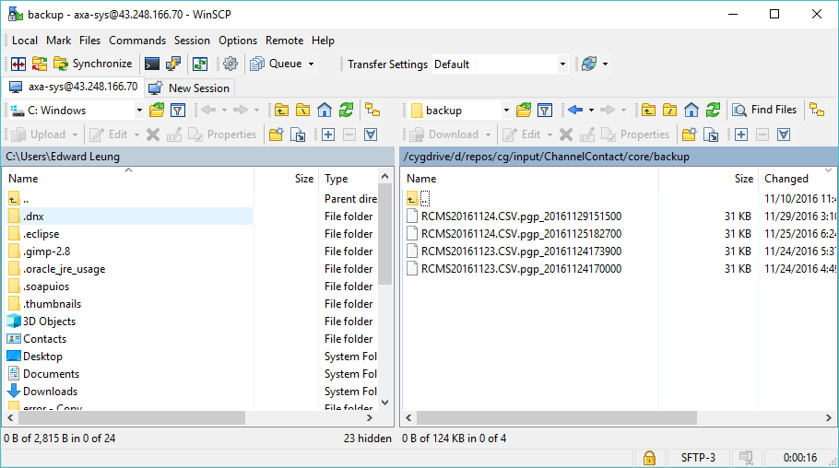

Check any file in the folder for T-1

### Recovery Steps

|  |  |  |  |
| --- | --- | --- | --- |
| **Recovery ID** | **Team** | **Env/Server** | **Steps** |
| R4.1 | NHR support team | NHR production system | 1. Login in to sftp.e-service-axa.com.hk.  2. If sftp server didn’t work, report incident to ATOS system support team.  3. Go to /cygdrive/d/repos/cg/input/ChannelContact/core/backup.  4. If there is no files of the T-1 date found in the folder, contact RCMS team.  E.g.: If today is 2016-12-16. T-1 should be 2016-12-15. You should be able to see RCMS20161215.CSV.pgg_20161216093300 found in the folder. |

## Task T5 – Check any error in RCMS files

This check helps to ensure there is no error encountered during the processing of RCMS channel contact file.

### Health check steps

|  |  |  |  |  |  |
| --- | --- | --- | --- | --- | --- |
| **Task ID** | **Team** | **Env/Server** | **Steps** | **Expect Results** | **Actions** |
| T5.1 | NHR support  team | NHR production system | 1. Login in to sftp.e-service-axa.com.hk.  2. Go to /cygdrive/d/repos/cg/input/ChannelContact/core/error.  3. Check whether there are files downloaded for T-1 date. | There should be **NO** file for T-1 date found. | Report incident to RCMS support team if there is error found in the folder. |

Figure 5.5.1

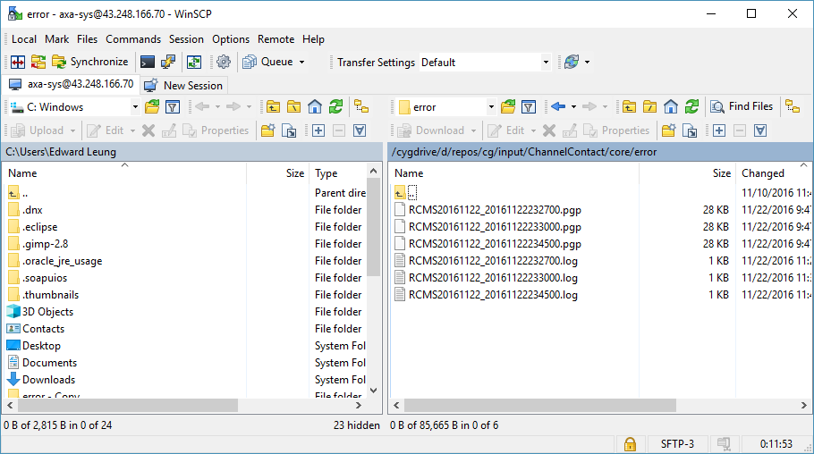

Check any file in the error folder for T-1

### Recovery Steps

|  |  |  |  |
| --- | --- | --- | --- |
| **Recovery ID** | **Team** | **Env/Server** | **Steps** |
| R5.1 | NHR support team | NHR production system | 1. Login in to sftp.e-service-axa.com.hk  2. If sftp server didn’t work, report incident to ATOS system support team  3. Go to /cygdrive/d/repos/cg/input/ChannelContact/core/error  4. If there are files of the T-1 date found in the folder, it means there are error found in RCMS file. Contact RCMS team  5. Send over the RCMS*.pgp*.* to RCMS team (T-1 date file. Original encrypted file and error log file)  E.g. If today is 2016-12-16. T-1 should be 2016-12-15. If there is file named RCMS20161215.CSV.prg_yyyymmddhhmmss found in the folder, contact RCMS team send over the files to the support team for investigation. |

## Task T6 – Check Number of Notifications Send Out

This check helps to ensure CG has notifications successfully delivered to customers / channels for a particular business date.

### Health check steps

|  |  |  |  |  |  |
| --- | --- | --- | --- | --- | --- |
| **Task ID** | **Team** | **Env/Server** | **Steps** | **Expect Results** | **Actions** |
| T6.1 | NHR support  team | NHR production system | 1. Login to CG <https://www.e-service-axa.com.hk/axa-notification-web>  2. Go to Status > System Health Dashboard.  3. Input T-1 in system date field. Click **Search** to check the delivery status by business line and its touchpoint. | There should be **NO** failure record in No. SMS Sent and No. of Email Error.  There should be successful notification message reveals in column No. SMS Sent and No. Email Sent. | Check the figures in the System Dashboard. |

Figure 5.6.1

Last Action Date (e.g. 2016/11/14)

Input System Date

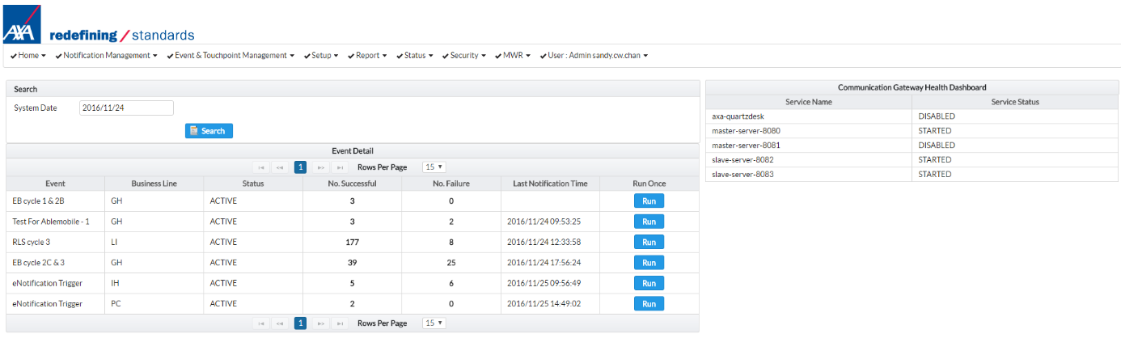

Component running status

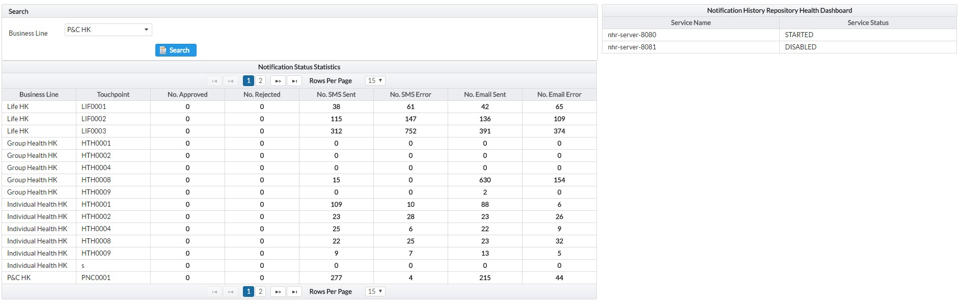

Business Line selected for searching

No. of SMS/Email sent according to System input

### Recovery Steps

|  |  |  |  |
| --- | --- | --- | --- |
| **Recovery ID** | **Team** | **Env/Server** | **Steps** |
| R6.1 | NHR support team | NHR production system | 1. Login to CG <https://www.e-service-axa.com.hk/axa-notification-web>.  2. Go to system health dashboard, select **current date** and check Event Date run or not.  3. Select **Report > Notification History** to check the status of related notification history record.  4. If all notification for T-1 date have delivery status equal to “**CG – AbleMobile Sent”**, contact AbleMobile support.  5. If the no notification incident is related to notification source file failure, contact Core System Team.  6. If the no notification incident is related to operator not yet approve record, asked related sub-business line operator to approve the record.  7. For other unknown issue, report incident to ATOS. |

# Appendix

## Communications

OneIT Production Team

|  |  |  |  |  |  |
| --- | --- | --- | --- | --- | --- |
| **Name** | **Title** | **Team** | **Office no.** | **Mobile no.** | **Email address** |
|  |  |  |  |  |  |
|  |  |  |  |  |  |

Application Support Team:

|  |  |  |  |  |  |
| --- | --- | --- | --- | --- | --- |
| **Name** | **Title** | **Team** | **Office no.** | **Mobile no.** | **Email address** |
| Wang Shichao |  | eBao support team | +86-20-3818 3333 Ext:82136 |  | Shichao.a.wang@avanade.com |
|  |  |  |  |  |  |
|  |  |  |  |  |  |
|  |  |  |  |  |  |

AXA TECH:

|  |  |  |  |  |  |
| --- | --- | --- | --- | --- | --- |
| **Name** | **Title** | **Team** | **Office no.** | **Mobile no.** | **Email address** |
|  |  |  |  |  |  |
|  |  |  |  |  |  |
|  |  |  |  |  |  |
|  |  |  |  |  |  |
|  |  |  |  |  |  |

1. RCMS - Regional Channel Management System